**VIRIDIAN METALS**

**IDENTIFIES OVER 150 CONDUCTORS ON KRAKEN MAGMATIC SULFIDE PROJECT**

***Not for distribution to U.S. news wire services or for dissemination in the United States***

Vancouver, B.C., Canada – November 20, 2024.Viridian Metals Inc. (TSXV:VRDN) (“Viridian”) formerly Coco Pool Corp.(“**Coco**”)is pleased to announce the receipt of a new interpretation of its high resolution TDEM data. Viridian engaged Southern Geoscience Consultants (“SGC”) of Perth Western Australia to evaluate the data collected in 2022 and interpret the results.

“The interpretation of our high-resolution geophysical data by SGC has unlocked a new perspective on the untapped potential across the entire Kraken Project," said Tyrell Sutherland, CEO and president of Viridian Metals. "By combining modern techniques with insights from historical work, we now have a powerful roadmap to further guide exploration efforts and fully realize the value of this asset."

Viridian contracted Southern Geoscience Consultants to interpret electromagnetic (EM) data, collected by Prospect Air over the Kraken Ni-Cu-Co Project Area. EM anomalies are produced by conductive bodies and may be indicative of sulfide mineralization. Highlights from the data and it’s interpretation include:

* A total of 169 linear conductors were identified, totalling over 64km of strike length
* Over 120 distinct conductors with a strike length greater than 250m
* Of the 169 conductor anomalies only 4 have been drill tested by Viridian or prior operators
* There are 24 conductors classified as “Priority 1” by SGC based on their strong signal and discrete electromagnetic response, of which only 2 have been drill tested
* Improved resolution in the airborne data collected by Viridian coupled with the interpretations by SGC explains why previous drilling by Kennecott and Teck failed to test key bedrock conductors.

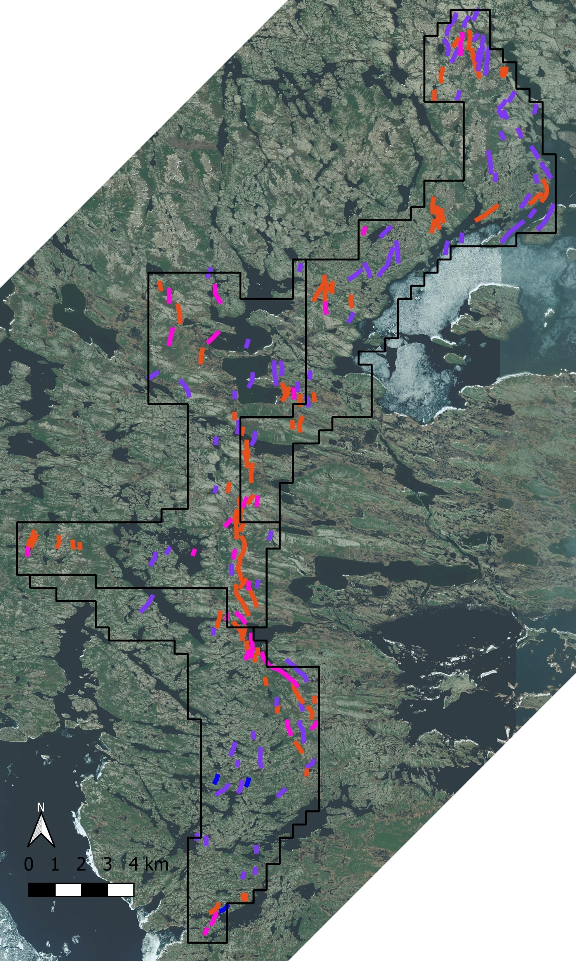

EM anomalies

Figure 1: Property scale map showing interpreted EM anomalies. Priority 1 anomalies in pink, Priority 2 in orange, Priority 3 in purple and Priority 4 in blue. Outset of EM Anomalies at the Neptune Zone showing historical drill hole traces in black.

SGC is a leading geophysical consulting firm with over 30 years of experience in providing expert geophysical solutions to the exploration and mining industry. Renowned for their innovative approaches and technical excellence, SGC specializes in the processing, interpretation, and integration of geophysical data to optimize exploration strategies. Their team of highly skilled geoscientists collaborates closely with clients to deliver tailored solutions that uncover new opportunities and maximize resource potential.

**About Viridian Metals**

Viridian Metals is a pioneer and leader in generative metal exploration with a focus on environmental responsibility and ethical practices. Founded with the intention of discovering new critical metals deposits with the potential to transform the metal supply chain. We leverage innovative technologies and methods to enhance efficiency and sustainability in jurisdictions eager to be leaders in supplying the energy transition. Viridian maintains expertise in a range of critical metals with a primary focus on copper, nickel and cobalt in the near term. Our commitment to integrity and transparency fosters strong partnerships with both local and global stakeholders.

*For further information, please contact:*

|  |
| --- |
| **Viridian Metals**  Tyrell Sutherland  President & CEO  Telephone: (613) 884-8332  Email: [Info@viridianmetals.com](mailto:Info@viridianmetals.com) |

***This press release has been reviewed and approved by Mr. Tyrell Sutherland M.Sc., P.Geo., a “qualified person” as defined in National Instrument 43-101 - Standards of Disclosure for Mineral Projects***

**Cautionary Statement Regarding Forward Looking Information**

*This news release contains statements which constitute “forward-looking information” within the meaning of applicable securities laws, including statements regarding the plans, intentions, beliefs and current expectations of the Company with respect to future business activities and operating performance.*

*Often, but not always, forward-looking information can be identified by the use of words such as “plans”, “expects”, “is expected”, “budget”, “scheduled”, “estimates”, “forecasts”, “intends”, “anticipates”, or “believes” or variations (including negative variations) of such words and phrases, or statements formed in the future tense or indicating that certain actions, events or results “may”, “could”, “would”, “might” or “will” (or other variations of the forgoing) be taken, occur, be achieved, or come to pass. Forward-looking information includes, but is not limited to, information regarding: (i) the potential for mineralization at the Company’s mining properties including the Kraken Project (ii) the plans and expectations of the Company; and (iii) expectations in respect of other economic, business, and/or competitive factors.*

*Forward-looking information is based on currently available competitive, financial and economic data and operating plans, strategies or beliefs as of the date of this news release, but involve known and unknown risks, uncertainties, assumptions and other factors that may cause the actual results, performance or achievements of the Company, to be materially different from any future results, performance or achievements expressed or implied by the forward-looking information. Such factors may be based on information currently available to the Company, including information obtained from third-party industry analysts and other third-party sources, and are based on management’s current expectations or beliefs. Any and all forward-looking information contained in this news release is expressly qualified by this cautionary statement.*

*Investors are cautioned that forward-looking information is not based on historical facts but instead reflect management’s expectations, estimates or projections concerning future results or events based on the opinions, assumptions and estimates of management considered reasonable at the date the statements are made. Forward-looking information reflects the Company’s current beliefs and is based on information currently available to it and on assumptions it believes to be not unreasonable in light of all of the circumstances. In some instances, material factors or assumptions are discussed in this news release in connection with statements containing forward-looking information. Such material factors and assumptions include but are not limited to the factors set forth in the Company’s Filing Statement dated October 28, 2024 under the caption “Risk Factors”. Although the Company has attempted to identify important factors that could cause actual actions, events or results to differ materially from those described in forward-looking information, there may be other factors that cause actions, events or results to differ from those anticipated, estimated or intended.*

*Forward-looking information contained herein is made as of the date of this news release and, other than as required by law, the Company disclaims any obligation to update any forward-looking information, whether as a result of new information, future events or results or otherwise. There can be no assurance that forward-looking information will prove to be accurate, as actual results and future events could differ materially from those anticipated in such statements. Accordingly, readers should not place undue reliance on forward-looking information. Should one or more of these risks or uncertainties materialize, or should assumptions underlying the forward-looking information prove incorrect, actual results may vary materially from those described herein as intended, planned, anticipated, believed, estimated or expected.*